Ans 1 – There are numerous ways to apply conditional formatting and there are mainly 5 types of conditional formatting which can be found on HOME tab under Conditional formatting icon are as follows;

1. Highlight Cell Rules – this formatting type works for values in specific cells, for example – value between 50 and 150; values less than or equal to 80; also helps to identify the duplicates values in selected range or column etc.
2. Top/Bottom Rules – again this is similar to Highlight Cell Rules i.e. works for values in specific cells but works better if we want to get the formatting done for the Top most or Bottom values using specific criteria for example – Top 10%, Top 10 values in a column/row etc.
3. Data Bars – The relationship of values in a cell range. It will increase the size of the data bars across the cells whose value is more than the other based on the specified criteria. For example – comparison of prices.
4. Color scales - – The relationship of values in a cell range where a color is applied where the intensity of the cell’s color reflects the where the value is placed towards the top to bottom range. For example, population of a country in different states/cities.
5. Icon Sets – This condition implements icons in the selected cell range based on their cell values. For example- we can assign 3-5 icons to a group of cells which contains the profits or losses for a company.

Apart from these conditions we can also set conditions on whatever criteria that we want B y clicking on **New Rule** under Conditional formatting icon we can customize or set a new rule n th basis of which excel will do the formatting.

Ans 2 – First select the cell range on which you want to apply the border. After selecting the range go to HOME tab and click on down arrow icon next to **BORDERS,** then pick a border style which you want to apply. If you apply a border to a selected cell, the border is also applied to adjacent cells that share a bordered cell boundary. For example, if you apply a box border to enclose the range aA1:B5, the cells C1:C5 acquire a left border.

We can also create or customize **BORDERS** by clicking down arrow icon next to **BORDERS** icon and go to More Borders.

We can also Draw Borders as we want by going to Home clicking down arrow icon next to **BORDERS** icon > Draw Border .

We can draw border grid, erase it, change the line color etc.

Ans 3 – We can change the numbers format to currency by HOME > Number format option> change it to Currency.

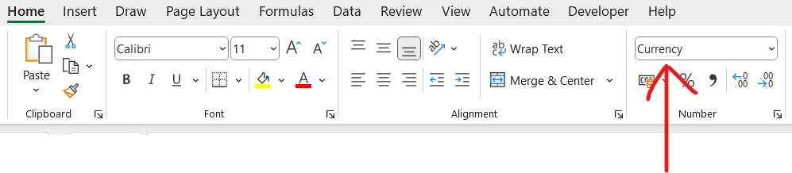Change the currency as per the country currency symbol from the below image;

We can also change the format by right clicking on the selected cells. A list will appear. Selecting Format Cells option from the list.

Now by selecting the symbol dropdown we can change the currency symbol.

Ans 4 – There are numerous ways to change the format of a number to percent style;

* We can select the cell range for which we need to change the format of cells from number to percent, then we can click on the % sign from the HOME tab. For example – in the below image Col A contains the number and if we try to change the format with this method, results will be the same as in Col B:

In mathematics, a percentage is a number expressed as a fraction of 100. The word percent literally means "per one hundred". For example, 65% is read as "Sixty-five percent" and is equivalent to 65/100 or 0.65. therefore, A4 contains number 1 according to which corresponding result will become 100%

* We can also change the format to percent from the format dropdown and select “percentage” and it will work the same way as it worked for the “%” character also will display the same results
* The 3rd way to change the format to percentage is by clicking on the number group from the HOME tab and it will open a dialogue box ( we can also open this dialogue box by pressing ctrl + 1). On the decimal places we can enter the decimal places that we want to display. For ex- if you want to display 25% in place of 25.00% then enter ) in decimal places section.

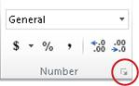

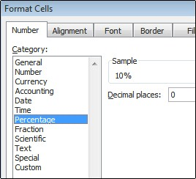

* We can also use the TEXT function for this for example – TEXT(0.25, “0.0%”), this will give use the result as 25%.

Ans 5 – first we need to select the cell range which we want to merge, after highlighting the range press ALT+H+M+M in a quick session.

Ans 6 – In order to use Text commands there are 2 ways. We can either use it by calling the function or by opening the format dialogue box by pressing ctrl +1 in a quick session both of them w0orks the same way.

* Syntax on TEXT function = TEXT(value which we want to format, “ format type in which we the value to be ”). There are numerous examples for these like ; Text(TODAY(), “DDDD” ) this will give the result of today’s day of the week like MONDAY; TEXT(0.285,”0.0%”) this will give us the result as 28.5% etc.
* Other method will be by pressing CTRL + 1 to open the FORMAT Cells dialogue box > go to CUSTOM option > Now in the “type box” it will show the format code in the below scenario format code is “0.00” and in sample it will show how your selected cell will display > copy the format code 0.00, close the dialogue box and paste the format code in TEXT formulae

Like – TEXT(23, “0.00”), the result will come up as – 23.00.

